 East West University

LAB REPORT

Course Code and Name:
CSE 209 ; ELECTRICAL CIRCUIT

Experiment no: 05
Group no: Individual
Experiment name:
Bias Point Detail Analysis of DC Circuit With Dependent Sources Using PSpice
Schematics
Name of student & Id:

B M Sharhia Alam | ID: 2021-3-60-016
Course Instructor information:
M Saddam Hossain Khan(SHK)
Senior Lecturer
Department of Computer Science and Engineering
East West University

Date of Report Submitted:
11 December ,2022

OBJECTIVE:

1. To analyze Bias Point Detail of DC circuit with dependent source using PSpice Schematics.

THEORY AND EXPERIMENTAL METHODS:

In electric circuit there are two types of sources:
1. Independent source
2. Dependent source.

Dependent source contains two elements such as the controlling element and the controlled element which either can be current or voltage.
There are also four types of dependent source. They are:
1. Voltage-controlled voltage source (VCVS)
2. Voltage-controlled current source (VCCS)
3. Current-controlled voltage source (CCVS)
4. Current-controlled current source (CCCS)

But in PSpice they are described with different symbols or alphabets. Which are:
1. Voltage-controlled voltage source (VCVS) as E1.
2. Voltage-controlled current source (VCCS) as G1.
3. Current-controlled voltage source (CCVS) as H1.
4. Current-controlled current source (CCCS) as F1.

CIRCUIT DIAGRAM:

Figure 2

* Schematics Netlist *
V_V1 1 0 10V
R_R1 1 3 8
R_R2 5 3 16
R_R3 0 5 4
R_R4 4 $N_0001 20
R_R5 0 4 8
E_E1 3 $N_0001 5 0 0.5

Figure 5
* Schematics Netlist *
R_R4 4 3 20
R_R1 1 2 8
R_R2 a 2 16
R_R3 0 a 4
R_R5 4 0 8
V_V1 1 0 10V
G_G1 3 2 0 a 0.5

Figure 7

* Schematics Netlist *
V_V1 1 0 10V
R_R1 1 a 8
R_R2 5 b 16
R_R4 4 3 20
R_R5 4 0 8
R_R3 0 5 4
H_H1 a 3 VH_H1 0.5
VH_H1 a b 0V

Figure 9

* Schematics Netlist *
V_V1 1 0 10V
R_R1 1 a 8
R_R2 5 b 16
R_R3 0 5 4
R_R4 4 3 20
R_R5 4 0 8
F_F1 3 a VF_F1 0.5
VF_F1 a b 0V
Figure 11

* Schematics Netlist *
G_G1 5 2 c 0 0.5
H_H1 2 3 VH_H1 0.5
VH_H1 a b 0V
V_V1 a 0 10
R_R3 0 6 4
R_R5 c 0 8
R_R4 c 3 20
R_R2 6 5 16
R_R1 b 2 8

Post-Lab Report Answers:

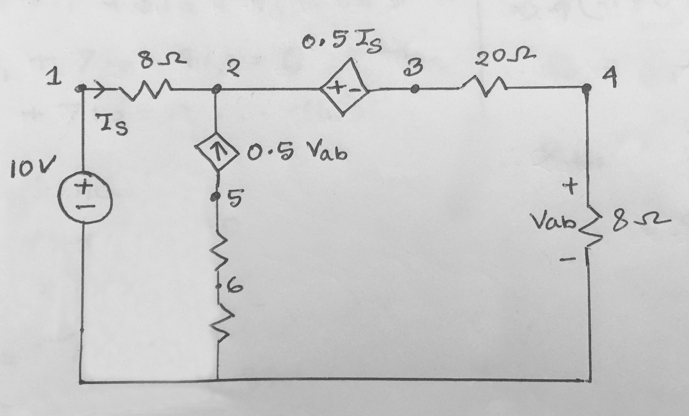

Answers to the questions no: 01

From the figure,
Is = 𝑖1
𝑉𝑎𝑏= 8𝑖2
KVL at Super-mesh,
-10 + 8𝑖1 + 0.5Is + 20𝑖2 + 8𝑖2 = 0
⇒-10 + 8𝑖1 + 0.5𝑖1 + 20𝑖2 + 8𝑖2 = 0 [⸪Is=𝑖1]
⇒8.5𝑖1+ 28𝑖2 = 10………………….(i)
Then,
𝑖2− 𝑖1−0.5Vab=0
⇒ 𝑖2 − 𝑖1 −0.5 ×8𝑖2=0 [⸪𝑉𝑎𝑏= 8𝑖2]
⇒𝑖1+3𝑖2 = 0…………………………(ii)

From equation (i) and (ii) we get,
𝑖1 = -12A
𝑖2 = 4A
So,
iₒ = 𝑖2 – 𝑖1
= 4 – (-12)
= 16A
Now, Voltage at Node 1,
𝑉1 = 10V

Voltage at Node 2,
Applying KCL at Node 2,
𝑉2 −108 − 𝑉2 −0.5𝐼𝑠28=16
⇒𝑉2 8−108+𝑉2 28−0.5×(−12)28 =16
⇒9𝑉2 56=47728
⇒𝑉2 =106V

Voltage at Node 3,
𝑖2 = 4A
R= 20+8
=28Ω
𝑉3 = (4 × 28)
= 112V

Voltage at Node 4,
𝑖2 = 4A
R = 8Ω
𝑉4 = (4 × 8)
= 32V

Voltage at Node 5,
iₒ = 16A
R = 16+4
=20Ω
𝑉5 = - (16 × 20)
= -320V
Voltage at Node 6,
iₒ= 16A
R= 4Ω
𝑉6 = - (16 × 4)
= -64V

So,
V1 = 10V
𝑉2 =106V
𝑉3 = 112V
𝑉4 = 32V
𝑉5 = -320V
𝑉6 = -64V
𝑖1 = -12A
𝑖2 = 4A
iₒ= 16A

Answers to the questions no: 02

Compare the theoretical solution of the circuit with the solutions obtained from PSpice simulation:

 |  | Theoretical solution | PSpice solution
Current | 𝑖1 | -12A | 12A
 | 𝑖2 | 4A | 4A
 | iₒ | 16A | 16A
Voltages | 𝑉1 | 10V | 10V
 | 𝑉2 | 106V | 106V
 | 𝑉3 | 112V | 112V
 | 𝑉4 | 32V | 32V
 | 𝑉5 | -320V | -320V
 | 𝑉6 | -64V | -64V

Result:

By doing this experiment we are able to simulate our circuits using PSpice and test the results. Previously we had tested our circuits practically, but this is more efficient.

Conclusion:

While doing this experiments, the readings were taken very carefully. Though there is some difference between calculated value and PSpice value, at the end of the experiment we finally gained practical knowledge that how to work with PSpice Schematic and independent source.

